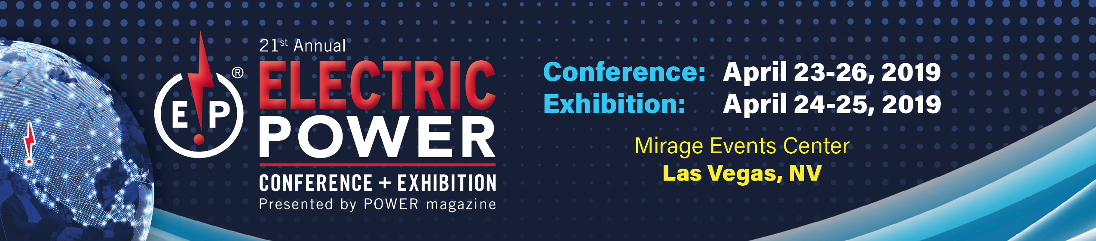
2019 ELECTRIC POWER CONFERENCE & EXHIBITION TRIP REPORT

Overview of Event:
The focus of the ELECTRIC POWER Conference was improving efficiency, performance, profitability, and safety procedures at the facility.
The conference was structured over the course of four days offering keynote sessions, roundtables, and breakout sessions led by experts in power generation. Ample time was left at the end of each session for questions and answers, allowing us an opportunity to gain feedback on specific areas of interest.
The Exhibition was located in the convention center where the conference was held, and all networking breaks were in the Exhibit Hall, allowing for multiple opportunities to visit with companies and investigate new products and services.
Summary of Conference Experience
During the conference, I was able to attend numerous sessions across seven tracks. I focused on topics that directly relate to my position at <insert company> and that provided solutions for the following projects:
- <insert ongoing project that will benefit>
- <insert ongoing project that will benefit>
- <insert ongoing project that will benefit>

Here are sessions I found particularly insightful and educational:
- <Insert Session Title, Name, and Speaker> – Include brief description along with 1-2 takeaways
- <Insert Session Title, Name, and Speaker> – Include brief description along with 1-2 takeaways
- <Insert Session Title, Name, and Speaker> – Include brief description along with 1-2 takeaways
- <Insert Session Title, Name, and Speaker> – Include brief description along with 1-2 takeaways
- <Insert Session Title, Name, and Speaker> – Include brief description along with 1-2 takeaways

Summary of Exhibition and Networking Events:
The chance to network with peers in similar situations was an extremely valuable experience, and I was also able to interact with vendors at the Exhibition. The opportunity to research new solutions and discuss current technologies with service experts was very worthwhile and may provide cost savings for <insert projects or upcoming purchases>. <List specific people, vendors or speakers you interacted with and the benefits of those discussions>

Conclusions/Recommendations
I was very pleased with the conference and learned new solutions and best practice strategies that can be implemented at <insert company name>. In addition, I gained valuable experience that couldn’t be obtained anywhere else. I was able to speak with several industry experts who provided tips and useful information for <insert specific challenges and work projects>.

The conference was very organized and the speakers provided candid opinions on the subject matter at hand, making the information extremely valuable. The Exhibit Hall provided a friendly, informative place to meet with vendors and view their products and services.
In addition, the meals and refreshment breaks were extremely nice and allowed me to save on my travel budget. I was very pleased with all that I received at the ELECTRIC POWER Conference and hope to attend again in 2020.
Follow-Up Actions

- Present overview at <insert department meeting or meeting with supervisor>
- Share conference proceeding access with <insert department or team>
- <Insert any additional follow-up actions in separate bullets>

